Name: Hitendra Sisodia

Sap Id: 500091910

**Aim:** Configure a Network using Distance Vector Routing protocol.

**Apparatus (Software):** packet tracer software

**Theory:**

In computer communication theory relating to packet-switched networks, a distance-vector routing protocol is one of the two major classes of routing protocols, the other major class being the link-state protocol. Distance-vector routing protocols use the Bellman–Ford algorithm, Ford–Fulkerson algorithm, or DUAL FSM (in the case of Cisco Systems’ protocols) to calculate paths. A distance-vector routing protocol requires that a router informs its neighbors of topology changes periodically. Compared to link-state protocols, which require a router to inform all the nodes in a network of topology changes, distance-vector routing protocols have less computational complexity and message overhead.

The Routing Information Protocol (RIP) is one of the oldest distance-vector routing protocols, which employs the hop count as a routing metric. RIP prevents routing

loops by implementing a limit on the number of hops allowed in a path from the source to a destination. The maximum number of hops allowed for RIP is 15. This hop limit, however, also limits the size of networks that RIP can support. A hop count of 16 is considered an infinite distance, in other words the route is considered unreachable.

# Procedure:

Step 1: First we will set up three routers.

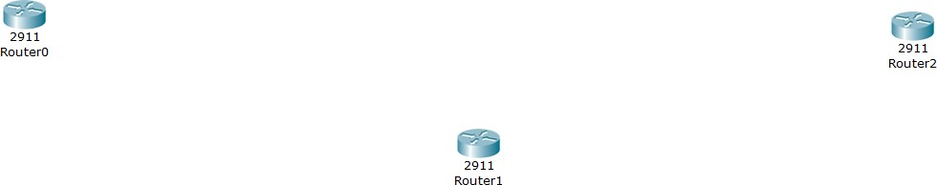

Step 2: Now we will take three switches, one for each router.

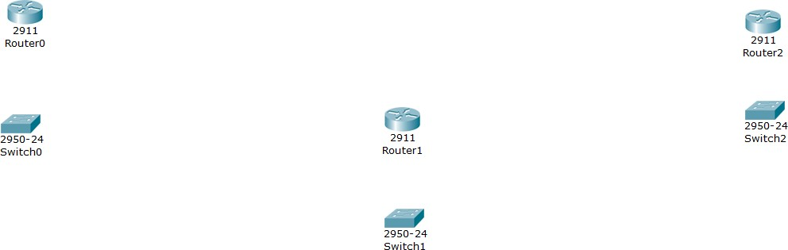

Step 3: Now we will take two end devices for each router.

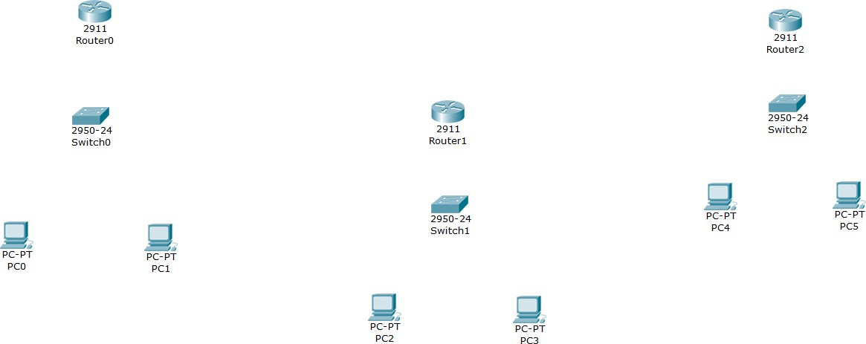

Step 4: The final topology should look like this:

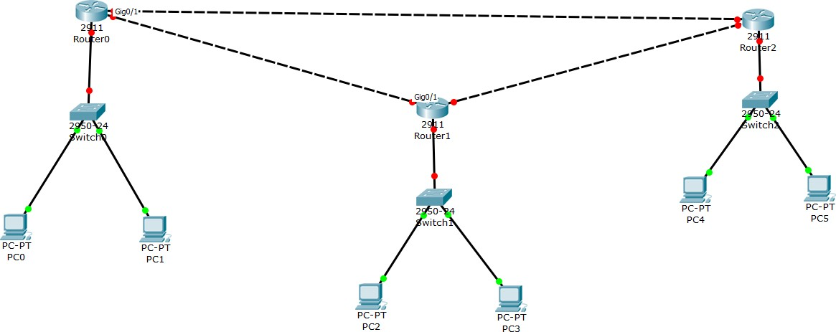

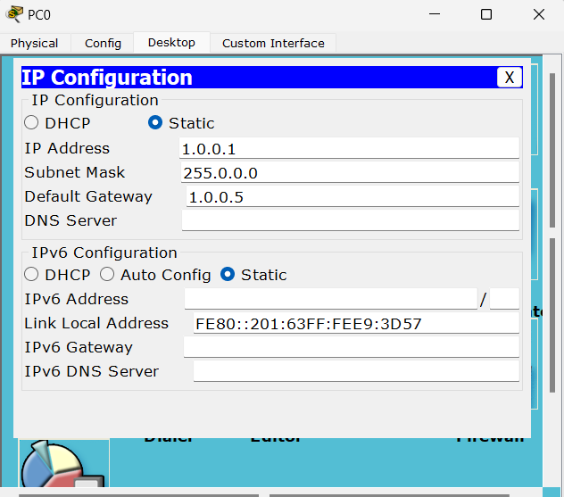Step 5: Now we will give IP address to each end device. Changing the config for PC0.

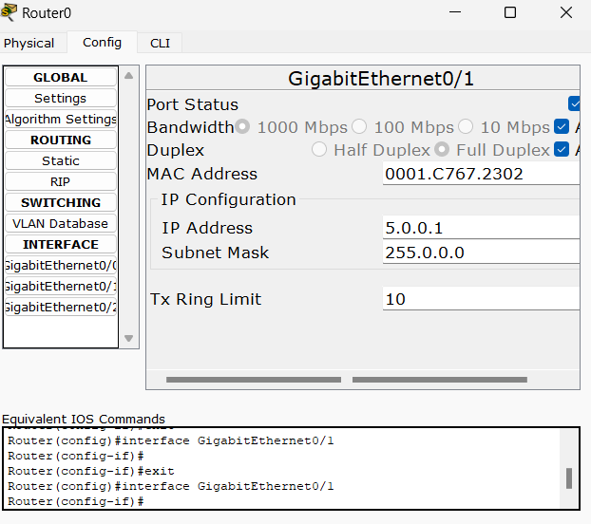Step 6: Similarly, we’ll change the config of other devices. Now, setting IP address for router0: 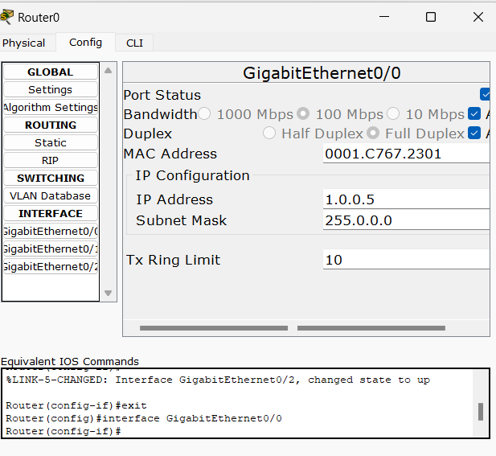

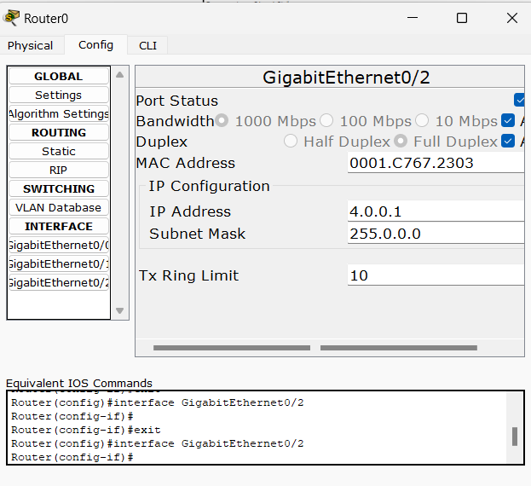

Step 7: Similarly, we’ll set up IP address for other routers.

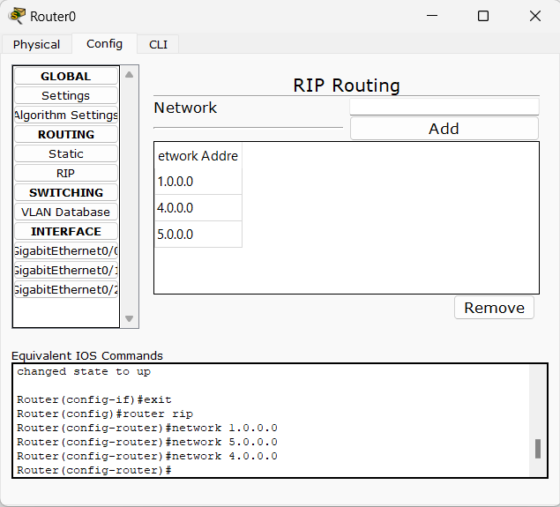Now we will add RIP (Network IP Address for each network connected to router). For Router0:

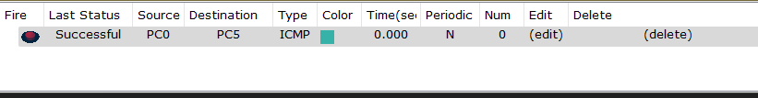Step 8: We’ll follow the same process for the other routers as well. Sending packet from PC0 to PC

Step 9: Sending packet from PC1 to PC4:

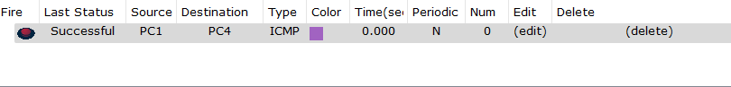**Conclusion:** Successfully the Distance vector routing protoc